Experiment - 3
Operating Systems Lab
Syeda Reeha Quasar
14114802719
6C7
AIM
To write the following shell programs:
- Program to find the greatest of 3 numbers.
- Program to find given number is odd or even.
- Program to check whether a given number is prime or not.

EXPERIMENT – 3

Aim:
To write the following shell programs:
- Program to find the greatest of 3 numbers.
- Program to find given number is odd or even.
- Program to check whether a given number is prime or not.

Source Code:

echo "Hello World!"
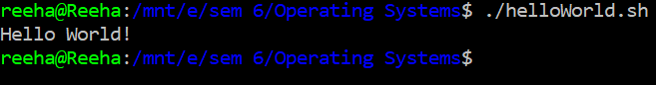

Program to find the greatest of 3 numbers:

echo "This is a program to find the greatest of 3 numbers"

echo "Enter 3 numbers"

read n1

read n2

read n3

echo "greatest number is:"

if [ $n1 -gt $n2 ] && [ $n1 -gt $n3 ]

then

echo $n1

elif [ $n2 -gt $n1 ] && [ $n2 -gt $n3 ]

then

echo $n2

else

echo $n3

fi

Output:

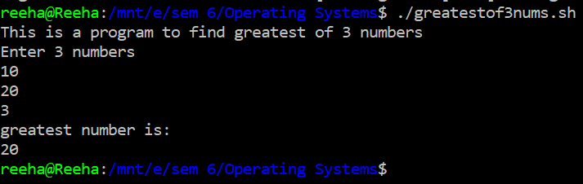

Program to find given number is odd or even:

echo "Program to find number is Odd or Even"
echo "Enter the number to check: "
read n
echo "Number is: "
if [ `expr $n % 2` == 0 ]
then
echo "Even"
else
echo "Odd"
fi

Output:

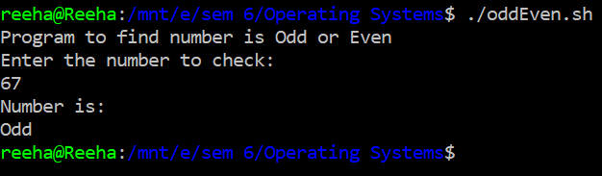

Program to check whether a given number is prime or not:

echo "Program to find number is Prime or Composite"
echo "Enter the number to check: "
read n
echo "Number is: "
for((i = 2; i * i <= n; i++))
do
if [ $((n % i)) == 0 ]
then
echo "Composite"
exit
fi
done
echo "Prime"

Output:

